**Perspectives On Future Top Metaverse Business Opportunities**

**Overview**

Although the subject of the Metaverse is popular, few individuals are knowledgeable about it, and businesses are confused if they ought to pay attention to it. Could anything that has received so much attention even be pertinent to their industry? The immediate answer is "yes." Numerous metaverse concepts have already materialised in the actual world. Others will soon. A lot of companies are investing in new methods to engage with their communities, boost sales, and deepen customer loyalty. The metaverse promises opportunities to enhance user experiences, create virtual-only products, and advertise both physical and digital goods and services. It will do all of this utilising its own banking and payment systems, and technology and software are required to enable all of these processes.

**The Doubtful Issues**

But there are other reasons to exercise care. The metaverse is now immensely popular despite the fact that the underlying technology trends have been there for years. This creation undoubtedly contains areas of speculation, overvaluation, and unwise investment, similar to the early internet, since a true metaverse as tech visionaries envisage it is still years away. Not every company today needs to become a metaverse leader. The good news is that by learning what the metaverse truly entails and adopting practical, affordable steps to achieve your company's objectives, you can distinguish reality from fantasy.

**The Fundamental Elements**

The processing power and storage required to enable immersive interfaces and extended reality are now provided via cloud computing systems. Hyperconnected networks with support for 5G are almost ready. Artificial intelligence (AI) is being used to create digital reflections that combine speech, computer vision, and deep learning to provide users authentic-feeling experiences. Due to the decentralisation of finance and the economy, which is made possible by blockchain, financial systems that are largely automated are now feasible. Last but not least, consumers who were born into the digital era and the pandemic's influence on purchasing habits are driving demand for the virtual products and experiences that the metaverse delivers.

**Opportunities for Business in the Future Metaverse**

**Retail platforms online**

The retail industry is one of the most important areas for testing metaverse business ideas. With the help of this immersive, metaverse-based shopping experience, all retail businesses might benefit.

Imagine yourself as a virtual avatar making a purchase at a store in the metaverse, exactly like you would in the real world. You may alter the appearance of your avatar by purchasing clothing and accessories from a store in the metaverse. The final option that best suits you may be taken into consideration. With this metaverse and retail firm combination, you may increase your earnings. In the Metaverse, start your own online store or mall where people may buy clothes.

**Digital properties**

The virtual depiction of real estate is yet another distinctive industry in the metaverse. Even if it appeals to certain business professionals, the idea of virtual real estate is very speculative.

Sales of real estate on prominent metaverse platforms like SandBox, Decentraland, Cryptovoxels, and Somnium totalled $5OOM in 2016 and are predicted to increase by a factor of two this year.

Every virtual land piece is distinct and protected by NFTs, which serve as ownership documentation.

The commercial notion of developing virtual lands will be increasingly successful.

**Streaming entertainment platforms**

The only streaming provider that is initially accessible online is Netflix. However, streaming services are now available on websites like Hulu, Amazon Prime, and others.

By incorporating a metaverse into game streaming and subscription services, you may provide gamers access to virtual reality area. Virtual reality headsets will be extensively utilised and generate significant money for manufacturers since Metaverse is all about virtual reality.

**Virtual workplaces and staff involvement**

Businesses may tremendously benefit from the metaverse by enabling their digitally upgraded environment. By linking employees, raising engagement, and promoting cooperation, organisations gain from adopting metaverse.

Many companies, including Microsoft, have created their own Metaverse, known as Microsoft Mesh, to encourage employee engagement. The metaverse may be used to provide your business access to a digitally upgraded workspace as a consequence.

**Comprehensive Learning Environment**

The infrastructure required for the immersive learning experiences offered by the metaverse is already there in the metaverse, thus the institution or particular organisation does not need to develop any new infrastructure.

Students will be able to more easily relate to a range of concepts and ideas through VR-based learning. Without respect to language restrictions, the metaverse can give learning experiences that help with problem-solving.

The military, higher education, the medical field, and many other academic fields will all greatly benefit from immersive learning possibilities in the metaverse.

Furthermore, you may launch your own Metaverse Education Platform where pupils and instructors can communicate in a 3D virtual setting.

**Conclusion**

Even if a metaverse based on web 3.0 design never completely materialises, adopting these actions may have a big advantage for your business. Many of the fundamental ideas that would form the cornerstone of a real metaverse are now advancing swiftly. In order to transform the digital economy, improve interoperability for digital environments, establish new governance norms, create more immersive and lasting digital experiences, and create digital identities that people and organisations can fully control, the pace of innovation is accelerating right now. These trends are still significant regardless of how the metaverse develops. If you begin going right away, your business could avoid falling behind. The metaverse probably has something related to your area of interest. After all, there are endless chances in a virtual world.

**Grammarly screenshot**

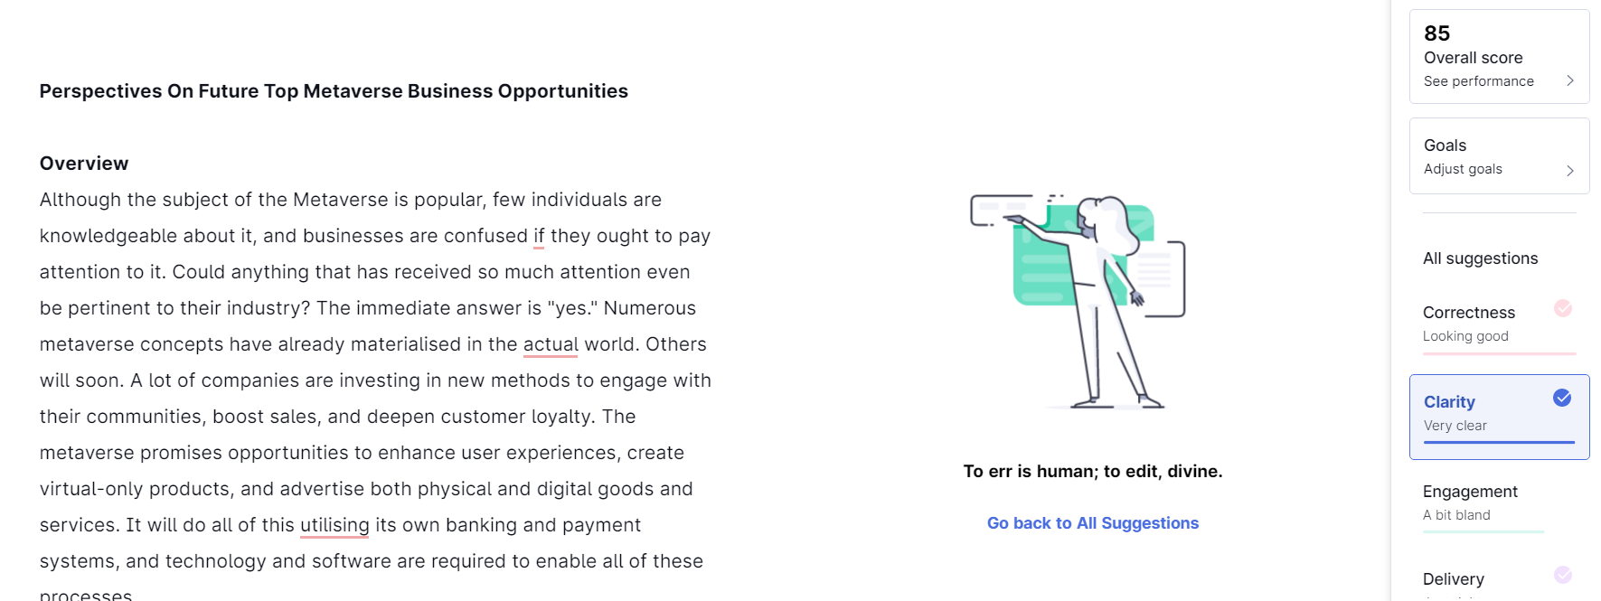

**Plagiarism check screenshot:**

